Game Design

Tap to increase money

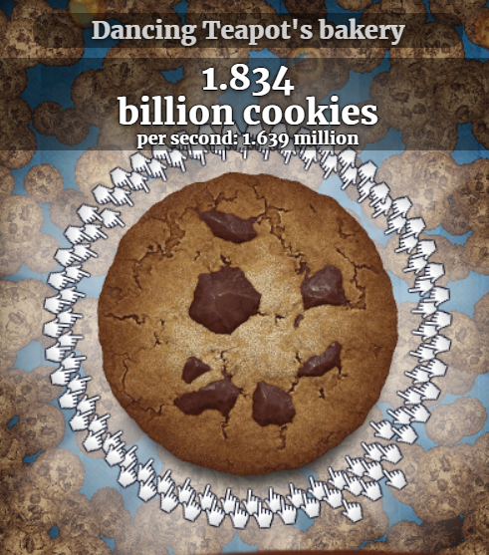

Buy skill to increase passive income and increase money per click

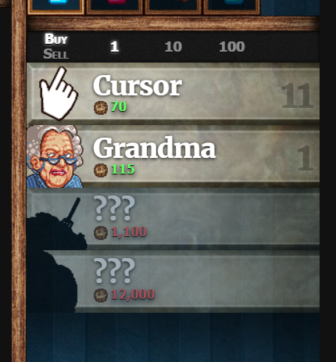

Buy powerup from store to increase skills power (twice..)

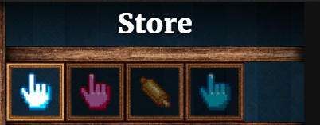

Click to a threshold cps for some second to get powered (autoclick 2x) on random cooldown (Events)

Use money to buy Fukuda customization

Tables

* User (username, password)
* Skill( skill upgrade list)
* Store (power up list)
* Stats
* Fukuda Customization
* Setting
* Events

EERD(link : https://drive.google.com/file/d/1qOWuVpo94jOJCajYtX2wI9oSJOAr3NXi/view?usp=sharing )

Rules:

1. Each user can buy many skills. Each skill can be bought by many users
2. Each user can buy many powerups. Each powerups can be bought by many users.
3. Each user can customize a Fukuda Customisation. Each Fukuda Customisation can be customized by only one user.
4. Each user has a stat. Each stat is owned by a user.
5. Each power up affected a skill. A skill may be affected by powerups.
6. Each User has a setting. Each setting belongs to a user.
7. Each user can have many events. Each events can be held by many users.

User Journey (Patt)

1. User เจอ Login Page
2. User register
3. User enter login page
4. User enter game page
5. User click fukuda to increase money
6. User buy skill to increase passive income and increase money per click
7. User buy powerup from store to increase skills power
8. User encounter an event
9. User click on customisation button
10. User change Fukuda appearance by click arrow button
11. User close customisation page
12. User click on setting
13. User change setting
14. User close setting
15. User click on stats
16. User read stats
17. User close stats

User Interface(Pon)

Database Design (Gus, Patt)

Slide()